Citrix Access GuideObjective
Citrix Workspace configuration for new users.

Step by Step
- • Open a web browser and access contoso.cloud.com
- • Click 'Don’t have a token?' to configure Citrix multi-factor authentication (MFA)
- • Enter your UPN
- • Click Next
- • You will receive an email from Citrix Cloud with your temporary verification code
- (Check the spam folder if the email is not in your inbox)
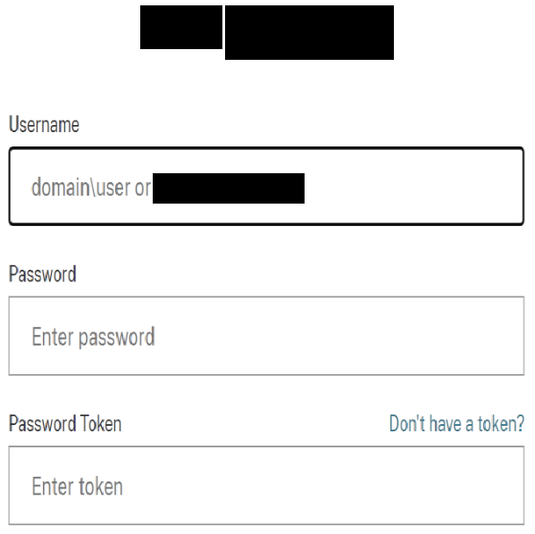
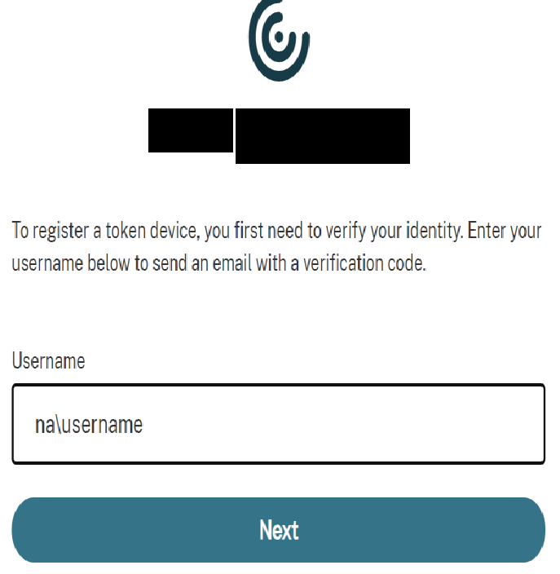
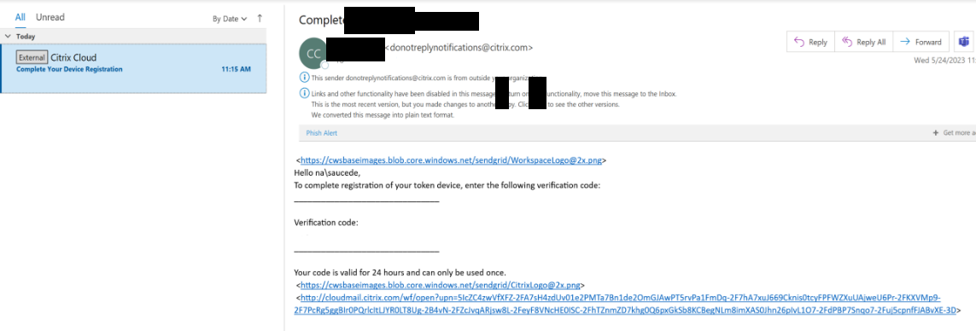
- • Enter the temporary verification code and your network password
- • Use the Authenticator app on your phone (Android or iPhone)
- • Scan the QR code displayed on the screen and follow the instructions to set up MFA
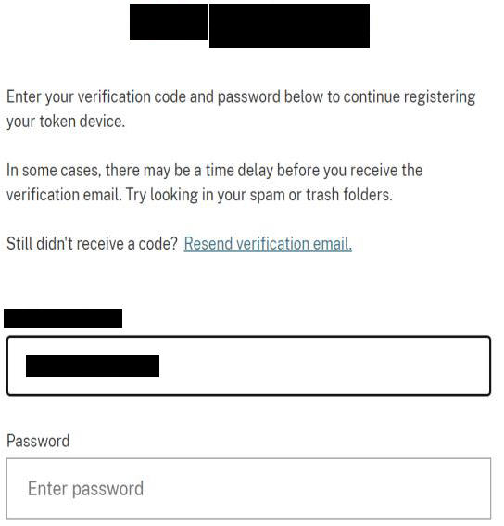
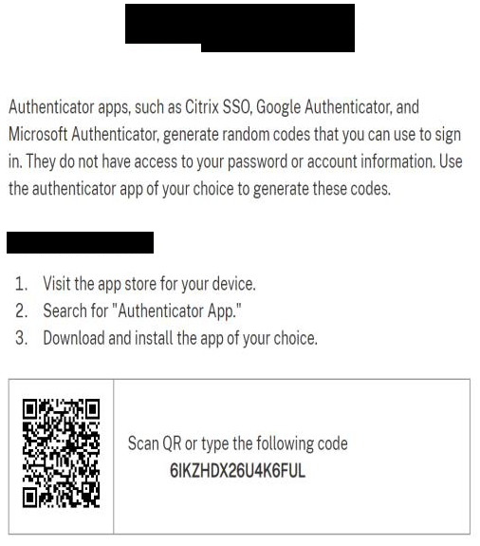

• Click Finish and Sign In
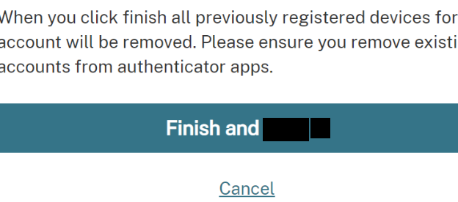

• Log in with your network credentials
- • Enter the authenticator app code and click Sign In
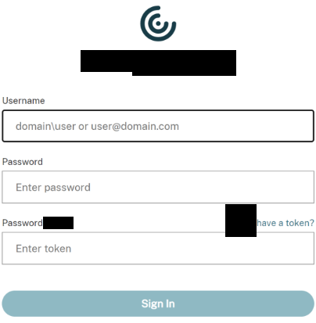
**You will need to authenticate every time you log in**

Version History
Author | Version | Date | Description
IT Team | 1.0 | 28/07/2025 | Creation
Lucas Souza | — | Jun/2026 | Document standardization

